
Skull Hill Brute CR 5
Orc barbarian 6 (Pathfinder RPG Bestiary 222)
CE Medium humanoid (orc)

Init +1; Senses darkvision 60 ft.; Perception +4
Defense
AC 15, touch 10, flat-footed 13 (+5 armor, +1 Dex, +1 dodge, -2 rage)
hp 74 (6d12+30)
Fort +9, Ref +3, Will +6; +3 morale bonus vs. spells, supernatural abilities, and spell-like abilities but must resist all spells, even allies'; +2 vs. traps)
Defensive Abilities ferocity, improved uncanny dodge, trap sense +2

Weaknesses light sensitivity
Offense
Speed 40 ft.
Melee +1 falchion +15/+10 (2d4+11/18-20)
Ranged javelin +7 (1d6+7)
Special Attacks rage (16 rounds/day), rage powers (powerful blow +2, strength surge +6, superstition +3)

Tactics
Before Combat Both orcs rage—this is figured into their stats.
During Combat The orcs attack whoever is closest and focus on that target until he or she has been knocked unconscious. Then they switch to the next closest and so on.
Morale The orcs fight to the death.
Base Statistics AC 17, touch 12, flat-footed 15 (+5 armor, +1 Dex, +1 dodge); hp 57 (6d12+18); Will +4; Melee +1 falchion +12/+7 (2d4+8/18–20); Ranged javelin +7 (1d6+5); Str 20, Con 14; CMB +11; CMD 23

Statistics

Str 24, Dex 13, Con 18, Int 8, Wis 10, Cha 6

Base Atk +6; CMB +13; CMD 23
Feats Dodge, Iron Will, Weapon Focus (falchion)
Skills Acrobatics +9 (+13 to jump), Climb +12, Intimidate +7, Perception +4, Survival +4, Swim +10
Languages Common, Orc
SQ fast movement
Combat Gear potion of cure light wounds (2), potion of cure moderate wounds; Other Gear +1 chain shirt, +1 falchion, javelin (3), 200 gp

Tracked Resources

Javelin -
Potion of cure light wounds -
Potion of cure moderate wounds -

Powerful Blow +2 (1/rage) (Ex) -
Rage (16 rounds/day) (Ex) - 0/16

Strength Surge +6 (1/rage) (Ex) -
Special Abilities
Ferocity (Ex) Fight without penalty even while disabled or dying.
Improved Uncanny Dodge (Lv >= 10) (Ex) Retain DEX bonus to AC when flat-footed. You cannot be flanked unless the attacker is Level 10+.
Light Sensitivity (Ex) Dazzled as long as he remains in bright light.
Powerful Blow +2 (1/rage) (Ex) One attack per rage deals extra damage.
Rage (16 rounds/day) (Ex) +4 Str, +4 Con, +2 to Will saves, -2 to AC when enraged.
Strength Surge +6 (1/rage) (Ex) As an immediate action, gain a bonus to one STR check, CMB or CMD.
Superstition +3 (Ex) While raging, gain bonus to save vs. magic, but must resist all spells, even allies'.

Skull Hill Rager CR 8
Male orc barbarian 9 (Pathfinder RPG Bestiary 222)
CE Medium humanoid (orc)

Init +2; Senses darkvision 60 ft.; Perception +5
Defense
AC 17, touch 11, flat-footed 14 (+6 armor, +2 Dex, +1 dodge, -2 rage)
hp 109 (9d12+45)
Fort +10, Ref +5, Will +7; +4 morale bonus vs. spells, supernatural abilities, and spell-like abilities but must resist all spells, even allies'; +3 vs. traps)
Defensive Abilities ferocity, improved uncanny dodge, trap sense +3; DR 1/—

Weaknesses light sensitivity
Offense
Speed 40 ft.
Melee +1 falchion +18/+13 (2d4+11/18-20)
Ranged javelin +11 (1d6+7)
Special Attacks rage (22 rounds/day), rage powers (powerful blow +3, roused anger, strength surge +9, superstition +4)

Tactics
Before Combat Both orcs rage—this is figured into their stats.
During Combat The orcs attack whoever is closest and focus on that target until he or she has been knocked unconscious. Then they switch to the next closest and so on.
Morale The orcs fight to the death.
Base Statistics AC 20, touch 14, flat-footed 16 (+6 armor, +1 Dex, +1 dodge); hp 85 (9d12+27); Will +6; Melee +1 falchion +16/+11 (2d4+8/18–20 plus Vital Strike); Ranged javelin +11 (1d6+5); Str 20, Con 14; CMB +15; CMD 28

Statistics

Str 24, Dex 14, Con 18, Int 8, Wis 10, Cha 6

Base Atk +9; CMB +16; CMD 27
Feats Dodge, Iron Will, Step Up, Vital Strike, Weapon Focus (falchion)
Skills Acrobatics +13 (+17 to jump), Climb +12, Intimidate +10, Perception +5, Survival +5, Swim +11
Languages Common, Orc
SQ fast movement
Combat Gear potion of cure serious wounds (2); Other Gear +2 chain shirt, +1 falchion, javelin (3), 220 pp

Tracked Resources

Javelin -

Potion of cure serious wounds -
Powerful Blow +3 (1/rage) (Ex) -

Rage (22 rounds/day) (Ex) - 0/22
Strength Surge +9 (1/rage) (Ex) -

Special Abilities
Ferocity (Ex) Fight without penalty even while disabled or dying¹.
Improved Uncanny Dodge (Lv >= 13) (Ex) Retain DEX bonus to AC when flat-footed. You cannot be flanked unless the attacker is Level 13+.
Light Sensitivity (Ex) Dazzled² as long as remain in bright light.
Powerful Blow +3 (1/rage) (Ex) One attack per rage deals extra damage.
Rage (22 rounds/day) (Ex) +4 Str, +4 Con , +2 to Will saves, -2 to AC when enraged.
Roused Anger (Ex) You can rage even when fatigued.
Step Up When a foe makes a 5 ft step away from you, you can move 5 ft to follow them.
Strength Surge +9 (1/rage) (Ex) As an imm action, gain a bonus to one STR check, CMB or CMD.
Superstition +4 (Ex) While raging, gain bonus to save vs. magic, but must resist all spells, even allies'.
Vital Strike Standard action: ×2 weapon damage dice.
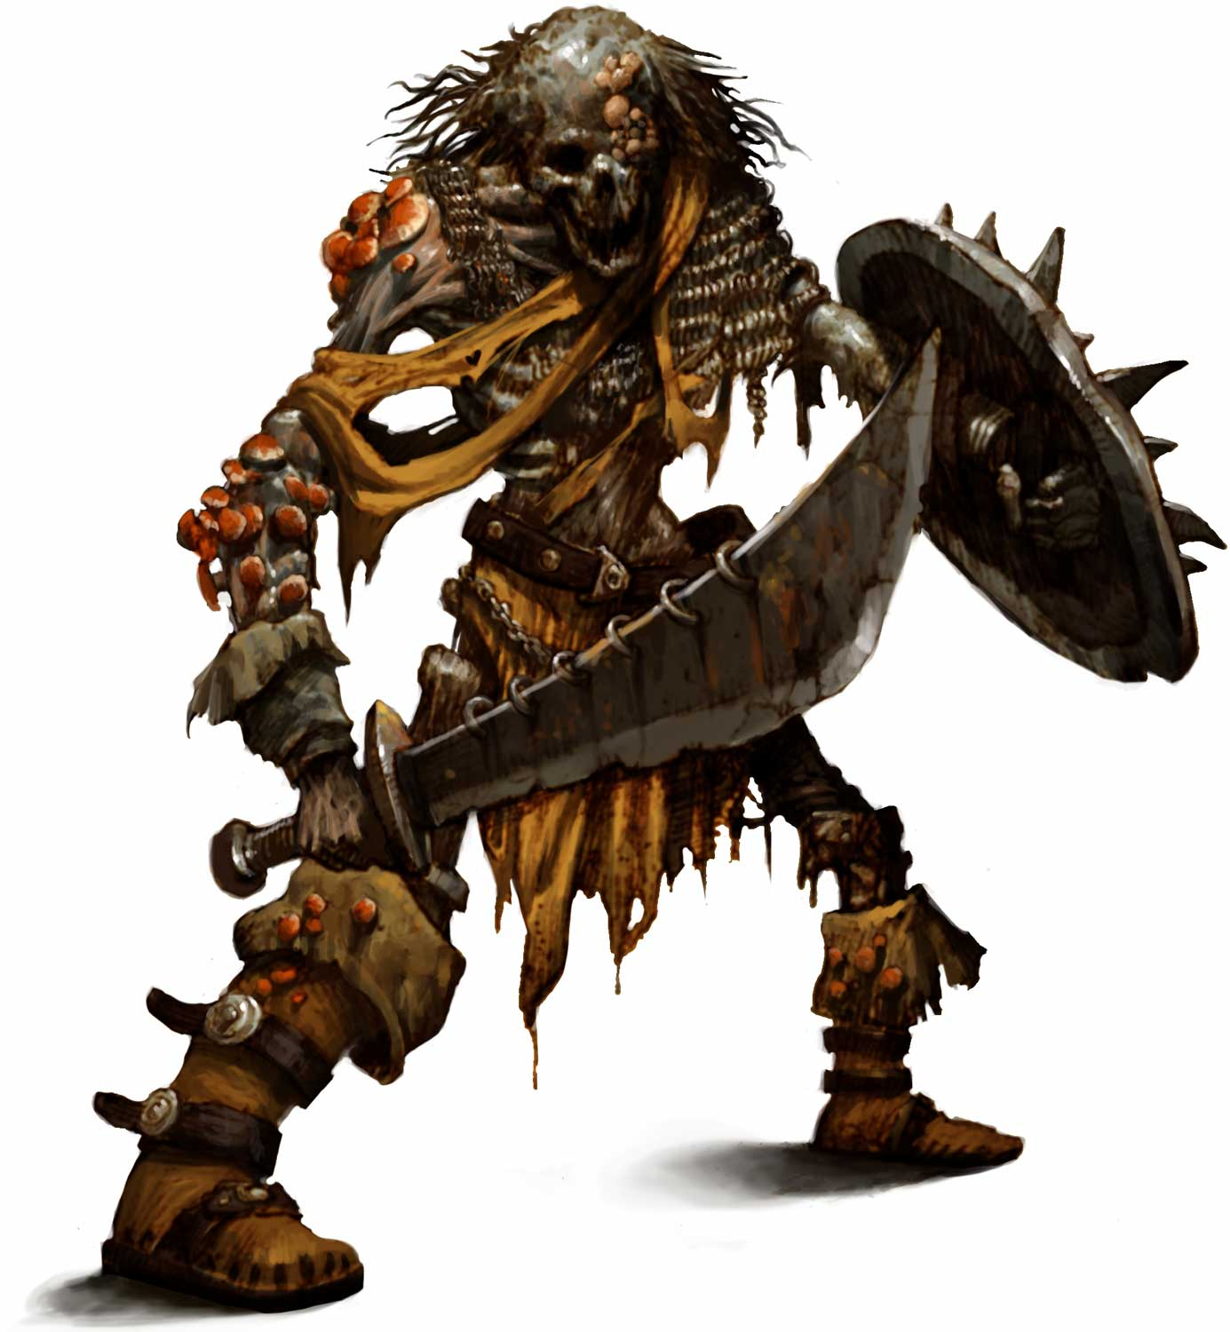Skeletal Champion Brute CR 5
Orc skeletal champion barbarian 6 (Pathfinder RPG Bestiary 222, 252)

CE Medium undead
Init +7; Senses darkvision 60 ft.; Perception +10

Defense
AC 19, touch 12, flat-footed 15 (+5 armor, +3 Dex, +1 dodge, +2 natural, -2 rage)
hp 59 (8 HD; 2d8+6d12+6)
Fort +5, Ref +5, Will +9; +3 morale bonus vs. spells, supernatural abilities, and spell-like abilities but must resist all spells, even allies'; +2 vs. traps)
Defensive Abilities channel resistance +4, ferocity, improved uncanny dodge, trap sense +2; DR 5/bludgeoning; Immune cold, undead traits

Weaknesses light sensitivity
Offense
Speed 40 ft.
Melee 2 claws +16 (1d4+8)
Special Attacks rage (12 rounds/day), rage powers (powerful blow +2, strength surge +6, superstition +3)

Tactics
Before Combat Once they spot the PCs, the skeletal champions rage. Rage has already been figured into their stats.
During Combat The skeletal champions possess great intelligence (for undead) and use it to flank the PCs and tactically retreat and strike again when they can. If a cleric uses his channel positive energy ability against the skeletal champions, they immediately focus all their rage on that PC.
Morale The skeletal champions fight until destroyed.
Base Statistics AC 21, touch 12, flat-footed 17 (+5 armor, +3 Dex, +1 dodge, +2 natural); hp 43 (6d12+18); Will +7; Melee +2 claws +14 (1d4+6); Str 22; CMB +13; CMD 27

Statistics

Str 26, Dex 16, Con —, Int 8, Wis 10, Cha 10

Base Atk +7; CMB +15; CMD 27
Feats Dodge, Improved Initiative, Iron Will, Weapon Focus (claw), Weapon Focus (falchion)
Skills Acrobatics +11 (+15 to jump), Climb +13, Intimidate +9, Perception +10, Survival +4, Swim +11
Languages Common, Orc
SQ fast movement
Other Gear +1 chain shirt, 200 gp
Tracked Resources

Powerful Blow +2 (1/rage) (Ex) -
Rage (12 rounds/day) (Ex) - 0/12

Strength Surge +6 (1/rage) (Ex) -
Special Abilities
Channel Resistance +4 +4 bonus to save vs. Channel Energy.
Ferocity (Ex) Fight without penalty even while disabled or dying¹.
Immunity to Mind-Affecting Effects, Bleed, Death Effects, Disease, Paralysis, Poison, Sleep Effects, Stunning, Nonlethal Damage, Ability Drain, Energy Drain, Ability Damage, Exhaustion, and Fatigue Effects Immune to mind-affecting effects, bleed, death effects, disease, paralysis, poison, sleep effects, stunning, nonlethal damage, ability drain, energy drain, ability damage, exhaustion, and fatigue effects.
Immunity to any effect that requires a Fortitude save (unless the effect also works on objects or is harmless).
Improved Uncanny Dodge (Lv >= 10) (Ex) Retain DEX bonus to AC when flat-footed. You cannot be flanked unless the attacker is Level 10+.
Light Sensitivity (Ex) Dazzled² as long as remain in bright light.
Powerful Blow +2 (1/rage) (Ex) One attack per rage deals extra damage.
Rage (12 rounds/day) (Ex) +4 Str, +4 Cha, +2 to Will saves, -2 to AC when enraged.
Strength Surge +6 (1/rage) (Ex) As an immediate action, gain a bonus to one STR check, CMB or CMD.
Superstition +3 (Ex) While raging, gain bonus to save vs. magic, but must resist all spells, even allies'.
Undead Traits Undead have many immunities.
Skeletal Champion Rager CR 6
Male orc skeletal champion barbarian 9 (Pathfinder RPG Bestiary 222, 252)

CE Medium undead
Init +8; Senses darkvision 60 ft.; Perception +13

Defense
AC 21, touch 13, flat-footed 16 (+6 armor, +4 Dex, +1 dodge, +2 natural, -2 rage)
hp 82 (11 HD; 2d8+9d12+9)
Fort +7, Ref +8, Will +11; +4 morale bonus vs. spells, supernatural abilities, and spell-like abilities but must resist all spells, even allies'; +3 vs. traps)
Defensive Abilities channel resistance +4, ferocity, improved uncanny dodge, trap sense +3; DR 1/—, 5/bludgeoning; Immune cold, undead traits

Weaknesses light sensitivity
Offense
Speed 40 ft.
Melee 2 claws +19 (1d4+8)
Special Attacks rage (18 rounds/day), rage powers (powerful blow +3, roused anger, strength surge +9, superstition +4)

Tactics
Before Combat Once they spot the PCs, the skeletal champions rage. Rage has already been figured into their stats.
During Combat The skeletal champions possess great intelligence (for undead) and use it to flank the PCs and tactically retreat and strike again when they can. If a cleric uses his channel positive energy ability against the skeletal champions, they immediately focus all of their rage on that PC.
Morale The skeletal champions fight until destroyed.
Base Statistics AC 23, touch 15, flat-footed 18 (+6 armor, +4 Dex, +1 dodge, +2 natural); Will +9; Melee 2 claws +17/+17 (1d4+6); Str 22; CMB +16; CMD 31

Statistics

Str 26, Dex 18, Con —, Int 8, Wis 10, Cha 10

Base Atk +10; CMB +18; CMD 31
Feats Dodge, Improved Initiative, Iron Will, Step Up, Vital Strike, Weapon Focus (claw), Weapon Focus (falchion)
Skills Acrobatics +14 (+18 to jump), Climb +12, Intimidate +12, Perception +13, Survival +5, Swim +12
Languages Common, Orc
SQ fast movement
Other Gear +2 chain shirt, cloak of resistance +1, 120 pp

Tracked Resources
Powerful Blow +3 (1/rage) (Ex) -

Rage (18 rounds/day) (Ex) - 0/18
Strength Surge +9 (1/rage) (Ex) -

Special Abilities
Channel Resistance +4 +4 bonus to save vs. Channel Energy.
Ferocity (Ex) Fight without penalty even while disabled or dying¹.
Immunity to Mind-Affecting Effects, Bleed, Death Effects, Disease, Paralysis, Poison, Sleep Effects, Stunning, Nonlethal Damage, Ability Drain, Energy Drain, Ability Damage, Exhaustion, and Fatigue Effects Immune to mind-affecting effects, bleed, death effects, disease, paralysis, poison, sleep effects, stunning, nonlethal damage, ability drain, energy drain, ability damage, exhaustion, and fatigue effects.
Immunity to any effect that requires a Fortitude save (unless the effect also works on objects or is harmless).
Improved Uncanny Dodge (Lv >= 13) (Ex) Retain DEX bonus to AC when flat-footed. You cannot be flanked unless the attacker is Level 13+.
Light Sensitivity (Ex) Dazzled² as long as remain in bright light.
Powerful Blow +3 (1/rage) (Ex) One attack per rage deals extra damage.
Rage (18 rounds/day) (Ex) +4 Str, +4 Cha, +2 to Will saves, -2 to AC when enraged.
Roused Anger (Ex) You can rage even when fatigued.
Step Up When a foe makes a 5 ft step away from you, you can move 5 ft to follow them.
Strength Surge +9 (1/rage) (Ex) As an immediate action, gain a bonus to one STR check, CMB or CMD.
Superstition +4 (Ex) While raging, gain bonus to save vs. magic, but must resist all spells, even allies'.
Undead Traits Undead have many immunities.
Vital Strike Standard action: ×2 weapon damage dice.
Krug, Moonflower Shaman CR 6
Male orc sorcerer 7 (Pathfinder RPG Bestiary 222)
N Medium humanoid (orc)

Init +2; Senses darkvision 60 ft.; Perception +1
Defense
AC 21, touch 13, flat-footed 19 (+4 armor, +1 deflection, +2 Dex, +4 shield)
hp 53 (7d6+26)
Fort +3, Ref +4, Will +4
Defensive Abilities ferocity; DR 5/lethal; Resist cold 5

Weaknesses light sensitivity
Offense
Speed 30 ft.
Melee mwk longspear +5 (1d8+1/×3)
Space 5 ft.; Reach 5 ft. (10 ft. with masterwork longspear)
Bloodline Spell-Like Abilities (CL 7th; concentration +11)
7/day—grave touch (3 rounds)
Sorcerer Spells Known (CL 7th; concentration +11)
3rd (5/day)—halt undead (DC 19), lightning bolt (DC 17), vampiric touch
2nd (7/day)—blindness/deafness (DC 18), false life, ghoul touch (DC 18), scorching ray
1st (7/day)—chill touch (DC 17), hold portal, mage armor, magic missile, ray of enfeeblement (DC 17), shield
0 (at will)—bleed (DC 16), daze (DC 14), detect magic, disrupt undead, read magic, resistance, touch of fatigue (DC 16)
Bloodline Undead

Tactics
Before Combat When Krug hears the PCs approach, he drinks a potion of eagle’s splendor and casts mage armor and shield on himself, in case the PCs are hostile.
During Combat Should the PCs fight Krug, he’s a fearsome ally. He starts with his highest level spells (lightning bolt if has range or vampiric touch if he’s close) and flees from melee attacks, making his way down to the first floor and out into the motte. If any melee PCs get close, he targets them with blindness/deafness and ghoul touch.
Morale Krug surrenders if brought below 5 hit points and begs the PCs to allow him to serve his Master (the moonflower in S1).
Base Statistics AC 12, touch 12, flat-footed 10 (+2 Dex); reduce all spell DCs by 2; Cha 14; Bluff +7, Diplomacy +6, Intimidate +14, Use Magic Device +7

Statistics

Str 12, Dex 14, Con 12, Int 11, Wis 8, Cha 18

Base Atk +3; CMB +4; CMD 17
Feats Arcane Strike, Combat Casting, Eschew Materials, Greater Spell Focus (necromancy), Persuasive, Spell Focus (necromancy)
Skills Acrobatics +5, Bluff +8, Diplomacy +7, Intimidate +16, Knowledge (arcana) +5, Perception +1, Spellcraft +5, Use Magic Device +8

Languages Common, Orc
SQ bloodline arcana (corporeal undead affected by humanoid-affecting spells)
Combat Gear lesser silent metamagic rod, potion of cure light wounds, potion of eagle's splendor (2), potion of invisibility; Other Gear mwk longspear, ring of protection +1

Tracked Resources

Potion of cure light wounds -
Potion of eagle's splendor -
Potion of invisibility -
Silent metamagic rod (lesser, 3/day) -

Special Abilities
Arcane Strike As a swift action, add +1 damage, +1 per 5 caster levels and your weapons are treated as magic for the purpose of overcoming damage reduction.
Bloodline Arcana: Undead (Ex) Formerly humanoid corporeal undead are humanoids for your mind-affecting spells.
Ferocity (Ex) Fight without penalty even while disabled or dying¹.
Grave Touch (3 rds, 7/day) (Sp) Starting at 1st level, you can make a melee touch attack as a standard action that causes a living creature to become shaken for a number of rounds equal to ½ your sorcerer level (minimum 1). If you touch a shaken creature with this ability, it becomes frightened for 1 round if it has fewer Hit Dice than your sorcerer level. You can use this ability a number of times per day equal to 3 + your Charisma modifier.
Greater Spell Focus (Necromancy) +1 to the Save DC of spells from one school.
Light Sensitivity (Ex) Dazzled² as long as remain in bright light.
Spell Focus (Necromancy) Spells from one school of magic have +1 to their save DC.
Krug, Moonflower Shaman (CR 9) CR 9
Male orc sorcerer 10 (Pathfinder RPG Bestiary 222)
N Medium humanoid (orc)
Init +2; Senses darkvision 60 ft.; Perception +1
Defense
AC 21, touch 13, flat-footed 19 (+4 armor, +1 deflection, +2 Dex, +4 shield)
hp 69 (10d6+32)
Fort +4, Ref +5, Will +8
Defensive Abilities ferocity; DR 10/lethal; Resist cold 10
Weaknesses light sensitivity
Offense
Speed 30 ft.
Melee mwk longspear +7 (1d8+1/×3)
Space 5 ft.; Reach 5 ft. (10 ft. with masterwork longspear)
Bloodline Spell-Like Abilities (CL 10th; concentration +12)
5/day—grave touch (5 rounds)
1/day—grasp of the dead (10d6 slashing, DC 17)
Sorcerer Spells Known (CL 10th; concentration +12)
5th (3/day)—blight (DC 19)
4th (5/day)—animate dead, fear (DC 18), ice storm
3rd (6/day)—halt undead (DC 17), hold person (DC 15), lightning bolt (DC 15), vampiric touch
2nd (7/day)—blindness/deafness (DC 16), false life, ghoul touch (DC 16), scorching ray, web (DC 14)
1st (7/day)—chill touch (DC 15), hold portal, mage armor, magic missile, ray of enfeeblement (DC 15), shield
0 (at will)—bleed (DC 14), daze (DC 12), detect magic, detect poison, disrupt undead, message, read magic, resistance, touch of fatigue (DC 14)
Bloodline Undead

Tactics
Before Combat When Krug hears the PCs approach, he drinks a potion of eagle’s splendor and casts mage armor and shield on himself, in case the PCs are hostile.
During Combat Should the PCs fight Krug, he’s a fearsome ally. He starts with his highest level spells (ice storm if has range or fear if he’s close) and flees from melee attacks, making his way down to the first floor and out into the motte. If any melee PCs get close, he targets them with blindness/deafness and ghoul touch.
Morale Krug surrenders if brought below 5 hit points and begs the PCs to allow him to serve his Master (the moonflower in S1).
Base Statistics AC 12, touch 12, flat-footed 10 (+2 Dex); reduce all spell DCs by 2; Cha 15; Bluff +8, Diplomacy +6, Intimidate +19, Use agic Device +8

Statistics

Str 12, Dex 14, Con 12, Int 11, Wis 8, Cha 15

Base Atk +5; CMB +6; CMD 19
Feats Arcane Strike, Combat Casting, Eschew Materials, Greater Spell Focus (necromancy), Iron Will, Persuasive, Spell Focus (necromancy)
Skills Acrobatics +5, Bluff +8, Diplomacy +5, Intimidate +19, Knowledge (arcana) +5, Perception +1, Spellcraft +5, Use Magic Device +8

Languages Common, Orc
SQ bloodline arcana (corporeal undead affected by humanoid-affecting spells)
Combat Gear lesser silent metamagic rod, potion of cure light wounds, potion of cure moderate wounds, potion of eagle's splendor (2), potion of invisibility, wand of expeditious retreat (50 charges); Other Gear mwk longspear, headband of alluring charisma +2, ring of protection +1

Tracked Resources

Potion of cure light wounds -

Potion of cure moderate wounds -
Potion of eagle's splendor -
Potion of invisibility -
Silent metamagic rod (lesser, 3/day) -

Wand of expeditious retreat (50 charges) - 0/50
Special Abilities
Arcane Strike As a swift action, add +1 damage, +1 per 5 caster levels and your weapons are treated as magic for the purpose of overcoming damage reduction.
Bloodline Arcana: Undead (Ex) Formerly humanoid corporeal undead are humanoids for your mind-affecting spells.
Ferocity (Ex) Fight without penalty even while disabled or dying¹.
Grasp of the Dead (10d6 slashing, 1/day, DC 17) (Sp) At 9th level, you can cause a swarm of skeletal arms to burst from the ground to rip and tear at your foes. The skeletal arms erupt from the ground in a 20-foot-radius burst. Anyone in this area takes 1d6 points of slashing damage per sorcerer level. Those caught in the area receive a Reflex save for half damage. Those who fail the save are unable to move for 1 round. The DC of this save is equal to 10 + ½ your sorcerer level + your Charisma modifier. The skeletal arms disappear after 1 round. The arms must burst up from a solid surface. At 9th level, you can use this ability once per day. At 17th level, you can use this ability twice per day. At 20th level, you can use this ability three times per day. This power has a range of 60 feet.
Grave Touch (5 rds, 5/day) (Sp) Starting at 1st level, you can make a melee touch attack as a standard action that causes a living creature to become shaken for a number of rounds equal to ½ your sorcerer level (minimum 1). If you touch a shaken creature with this ability, it becomes frightened for 1 round if it has fewer Hit Dice than your sorcerer level. You can use this ability a number of times per day equal to 3 + your Charisma modifier.
Greater Spell Focus (Necromancy) +1 to the Save DC of spells from one school.
Light Sensitivity (Ex) Dazzled² as long as remain in bright light.
Spell Focus (Necromancy) Spells from one school of magic have +1 to their save DC.
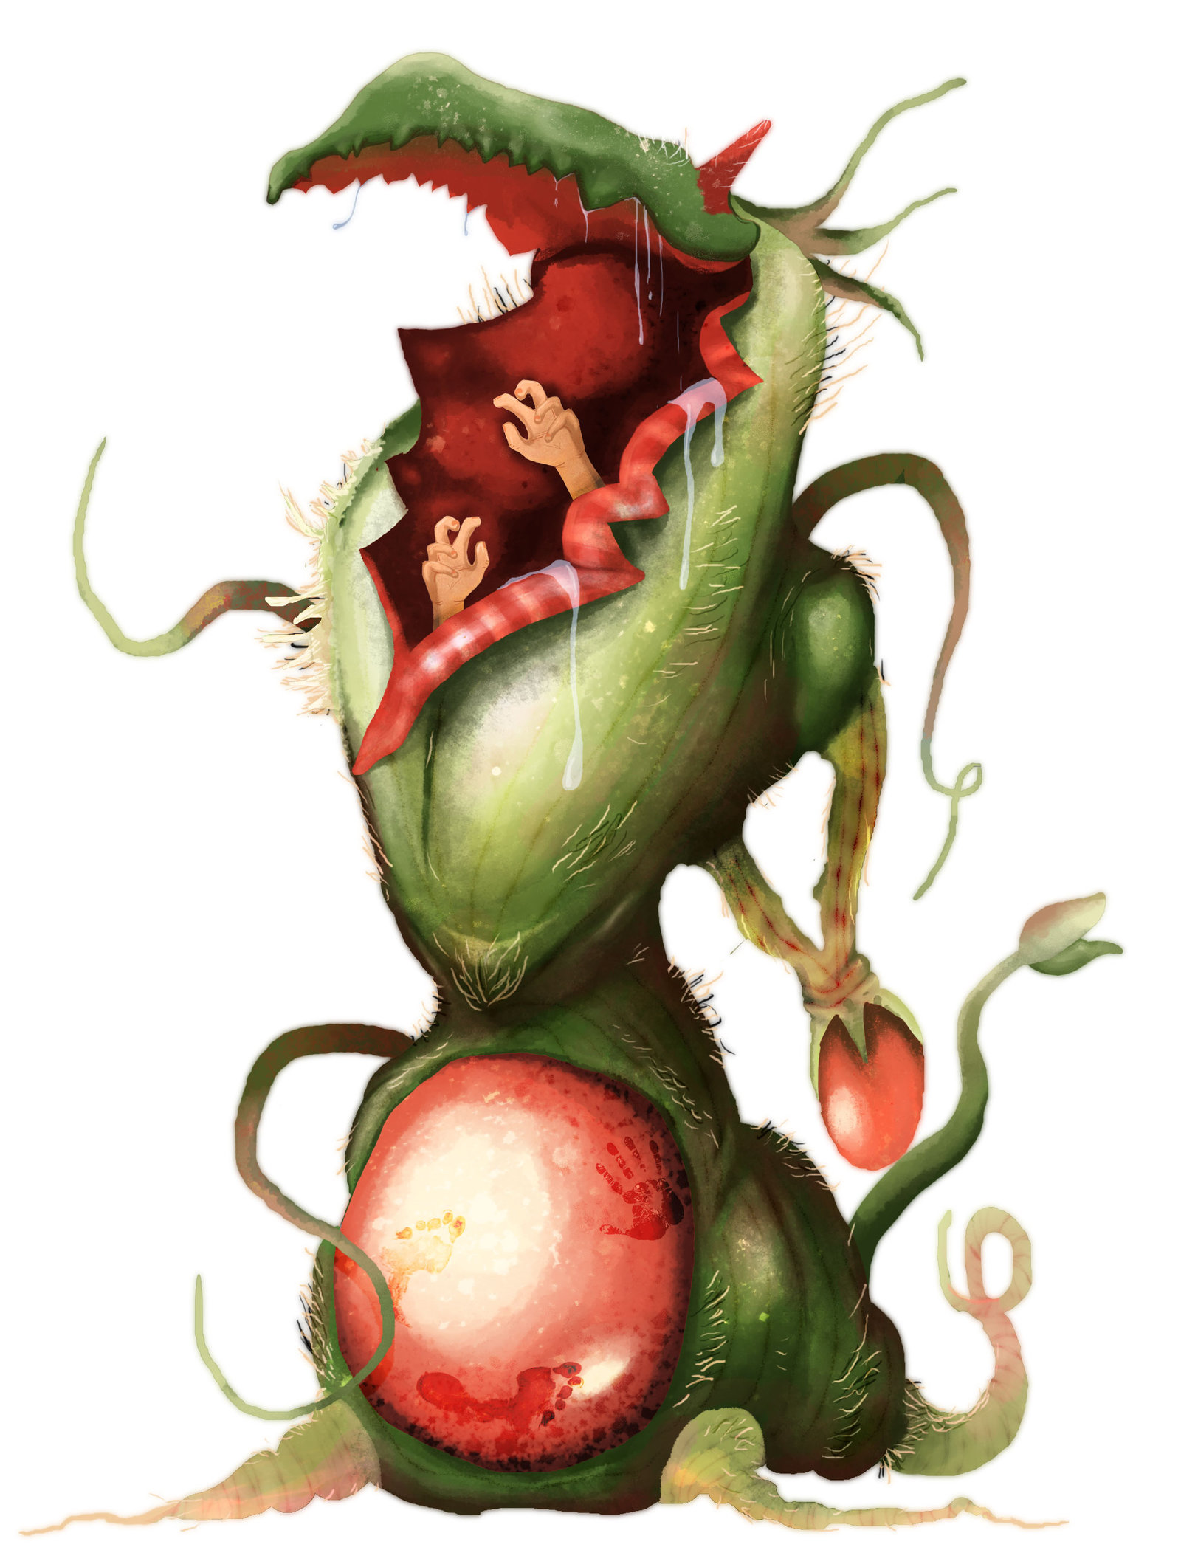A twisted trunk clustered with bulbous blossoms holds up a gaping mouth ready to swallow a victim whole.
Moonflower CR 8
Male moonflower (Pathfinder RPG Bestiary 2 192)

N Huge plant
Init +4; Senses darkvision 60 ft., low-light vision; Perception +9

Defense
AC 21, touch 8, flat-footed 21 (+13 natural, -2 size)
hp 104 (11d8+55); fast healing 5
Fort +12, Ref +3, Will +4
DR 10/slashing; Immune electricity, plant traits; Resist cold 10

Offense
Speed 20 ft.
Melee bite +15 (2d6+9 plus grab), 2 tentacles +13 (1d8+4)
Space 15 ft.; Reach 15 ft.

Special Attacks light pulse, pod prison
Statistics

Str 28, Dex 10, Con 21, Int 5, Wis 12, Cha 17
Base Atk +8; CMB +19 (+23 grapple, +21 sunder); CMD 29 (31 vs. sunder, can't be tripped)
Feats Blind-fight, Improved Initiative, Improved Sunder, Multiattack, Power Attack, Skill Focus (Stealth)
Skills Acrobatics +0 (-4 to jump), Perception +9, Stealth +4 (+20 in thick vegetation); Racial Modifiers +16 Stealth in thick vegetation
Languages telepathy (1 mile, other moonflowers only)

SQ pod spawn
Special Abilities
Blind-Fight Re-roll misses because of concealment, other benefits.
Grab: Bite (Huge) (Ex) You can start a grapple as a free action if you hit with the designated weapon.
Improved Sunder You don't provoke attacks of opportunity when sundering.
Immunity to Mind-Affecting Effects, Paralysis, Poison, Polymorph, Sleep, and Stunning Immunity to mind-affecting effects, paralysis, poison, polymorph, sleep effects, and stunning
Light Pulse (DC 20) (Su) As a standard action, a moonflower can release a pulse of bright light. All creatures within a 50- foot burst that can see the moonflower must make a DC 20 Fortitude save or be blinded for 1d4 rounds. Moonflowers are immune to this ability. The save
Plant Traits Plants have many immunities.
Pod Prison (2d6B + 2d6 Acid, AC 16, 10 HP) (Ex) This works like the swallow whole ability, except the moonflower can only use it once every 1d4 rounds, and the swallowed creature is immediately wrapped in a tight digestive cocoon and expelled into an adjacent square, where it takes damage every round (2d6 bludgeoning and 2d6 acid, AC 15, 25 hp). The cocooned target cannot use Escape Artist to get out of the cocoon. Other creatures can aid the target by attacking the cocoon with piercing or slashing weapons, but the creature within takes half the damage from any attack against the cocoon. Once the cocoon is destroyed, it deflates and decays. Each creature swallowed by a moonflower is encased in its own cocoon.
Pod Spawn (Ex) Should a moonflower’s pod prison kill and digest a small or larger creature, the pod transforms into an adult moonflower with full hit points after 1d4 hours. The newly formed moonflower has its own consciousness, but some aspect of its trunk or blossoms resembles the creature that died within. The dead creature’s equipment remains inside the new moonflower and can be retrieved by killing it.
Power Attack -3/+6 You can subtract from your attack roll to add to your damage.
Telepathy (1 mile, other moonflowers only) (Su) Communicate telepathically if the target has a language.

Up to the creature’s constitution score below zero.
The creature is unable to see well because of over-stimulation of the eyes. A dazzled creature takes a –1 penalty on attack rolls and sight-based Perception checks.

