Wrath of the Accursed | Sothis, Osirion
Scenario Type: sandbox investigation + dungeon crawl

Primary success condition:
End the Shadow Lodge’s terrorism of Sothis’ Pathfinder Lodge.

Secondary objective:
Rescue two of the missing Pathfinder agents.

Act 1: Scene 1 - Malhitu Bazaar |  | Kaphiri
Checks:
Diplomacy or Knowledge Local || DC 20 – If the check made to locate Kaphiri hits 20 or above they can skip the scene at his house.
Perception || DC 12 – players notice Kaphiri and his fellow guards on patrol, prompting Zahur to summon
Perception || DC 26 – allows the PCs to notice the summoned jackal and act in the surprise round
Perception || DC 16 – this is rolled by Kaphiri to act in the surprise round. He has a +11 modifier in the low-tier, and a +14 in the high.
Perception DC || 36 – This check is not outlined in the scenario, but given the bonus for invisibility, his Dex of 13, distance, and taking 10 on a Stealth check, this would be the DC to see Zahur flying away after summoning. I wouldn’t roll separately, but would mention a ‘warping of the air speeding away’ if they get this high while trying to see the jackal
Wisdom || DC 15 – this is rolled by Kaphiri, at a +0 modifier to determine that his weapon is the problem
 | Special Actions: The scenario says Day Job rolls can be made in this time. Considering the tone of urgency the scenario otherwise conveys, I think this is best left unmentioned.  Caster Level || DC 19 Dispel magic or remove curse will stop Kaphiri. |  |  | Loot:  +2 berserking khopesh

Act 1: Scene 2 |  | Uspia
Checks:
Knowledge (religion) || DC 20 – People who made the Sense Motive checks, or who worship Sarenrae are allowed a check to note the strangeness of a priest of the Dawnflower keeping her windows shuttered.
Perception || DC 30 – notice that the idol of Sarenrae has its eyes hammered shut, as well as the suspicious absence of other holy objects dedicated to the Dawnflower
Sense Motive || DC 21 – The scenario actually lack a stated check DC for seeing through Uspia’s lies. I made this up. My rationale is that with her CHA modifier of +1 and no ranks, a typical ‘Take 10’ DC would be too trivial for this tier, and from a ‘fluff’ perspective she may have been preparing lies for anyone who tries to interrupt her impromptu conversion.
Perception || DC 20 – This check is made after Uspia has been dealt with, and locates a small trapdoor leading to a basement. The basement contains the dead messenger from the lodge, as well as vegetables.
 | Special Actions:  The potion of haste has not been included in Uspia’s statistics. The elemental gem will summon a Large Fire Elemental, which I have included the statistics for at the bottom of this document. |  | Loot:  Uspia’s gear, remember that the elemental gem and potion of haste are likely to have been consumed.

Act 1: Scene 3 |  | Sutekh
Discussion:
Sutekh has been murdered in his shop using a scarab of death. The shop was locked afterwards by his assailants. PCs need to gain entrance, identify what has occurred, and leave. That’s all there is to it.
Checks:
Break || DC 20 or Disable Device || DC 30 – opens the locked door
Break || DC 25 - breaking the shutters off the window
Heal || DC 10 - identifies the HUGE GAPING HOLE IN THIS GUY’S CHEST as the cause of death. I figured it was probably cancer.
Knowledge (arcana) || DC 20 or Spellcraft || DC 24 – identifies the wounds as likely caused by a scarab of death
Loot:
None. All the potions have been given to legitimate clients before the PCs’ arrival.

Act 1: Scene 4 |  | Tarik
Discussion:
Agents of the Shadow Lodge have gone to great lengths to not only kill Pathfinders, but also discredit them. Uspia was made evil, Kaphiri made to go nuts in the middle of town, and now it’s the PCs’ turn. Tarik has already been murdered by the time the players arrive, but the shadow lodge has posted a lookout who will alert the guards to Tarik’s murder in an attempt to frame the party.
Investigation Checks: These checks are made during the 3-minute investigative element of this scene before the guards arrive, or after the guards are dealt with. I will make a separate section for the Exoneration portion.
Heal || DC 15 – identify suffocation as cause of death.
Perception || DC 20 – notice dusty footprints outside the doorway.
Craft (Pottery) || DC 20 – Put the pot back together to get the clue to go to the final dungeon. Let’s be honest for a moment, absolutely no one in the history of society play has ever taken enough ranks in Craft Fucking Pottery to make this check. Even if they did, there’s no listed duration this DC takes, and Craft rules default to days or weeks. Furthermore, the PCs aren’t actually firing and glazing a pot, they’re basically putting together a jigsaw puzzle. What I might do instead is either give the following Intelligence check, or make an out-of-game jigsaw type puzzle and time their solving it if they are still in Tarik’s house before the guards show up and subtract it from however much time they have left before the guards arrive. Don’t get me wrong, this scenario is awesome. This check, however, is an oversight.
Knowledge (local) || DC 25 – This indicates that the symbol on the bottom of the repaired pot belongs to the Ankh and Serpent Embalming House. I may also allow Diplomacy to Gather information to ask locals about the symbol.
Spellcraft || DC 22 – Identifies the aura of conjuration as belonging to the dust of sneezing and choking after casting detect magic.
Spellcraft || DC 25 – Identifies the aura of divination as belonging to the pot itself, some kind of ward that propelled the dust after it was given to Tarik.
 | Exoneration check:  Diplomacy || DC 40 – This calms the guards to prevent a combat or arrest. This check is aided by the following factors.  +10 – the players called the guards themselves  +10 – the players helped subdue Kaphiri earlier  +2 – mentioning relevant factors such as: Tarik’s cause of death (suffocation from the dust), “We’re all Pathfinders.”, talking about the cursed treasury of the Pharoah of Misfortune, other tasks around town the PCs have helped with like imprisoning Uspia, or reporting Sutekh’s death  +2 – aid another is allowed, but an attempt at aiding another that fails imposes a -2 penalty. |  |  | Consequences:
 |  |  |  | Party is arrested and held for 24 hours until Balentiir arrives and uses divination magic to exonerate the party.

Act 1: Intermissions
Discussion:
Nuru left for her monastery 3 months ago, but due to a clerical error notice of her departure has not been documented by the Sothis lodge. Her house is empty, and neighbors tell the party where she went.
Zahur, a Shadow Lodge sleeper agent, gave a false address to the lodge in the first place. They find a couple of spinsters trying to start a weaving business at the location documented. They have no idea who Zahur is, nor do any neighbors.
Sense Motive || DC 10 – reveals anyone the PCs are speaking to on the subjects to be hiding nothing.

Act 2: Scene 1 |  | Zahur
Discussion:
This scene is the entirety of Act II. Basically, the party is walking along and Zahur and his lady-admirer Lazuli ambush them. The fight begins once the party notices Lazuli. Every round that they fail to perceive her Zahur pre-buffs a bit more. I will include the descriptions for several of Zahur’s spells at the end of this document.
Checks:
Perception || DC 1d20 + 16 or 19 (tier dependent) This is how hard it is for the party to notice Lazuli, factoring in the distance penalty of 4 and her Stealth modifier. Any round where no one in the party succeeds allows Zahur to buff a bit more. As soon as someone notices her, she moves towards Zahur. At this point I would have her (if she is unseen after moving towards Zahur) hide in the entrance to the alley to try to get a sneak attack when the surprise round happens.

Area 3a: Reception Hall |  | Locked door
Discussion:
Pathfinders need to break in (the alley is abandoned) and…that’s basically it.
Checks:
Strength to break lock || DC 20
Disable Device || DC 25 also unlocks the door
Survival || DC 20 – notices tracks going back and forth in this room to the next

Area 3b: Preparation Hall |  | Spooky Undead
Discussion:
If character spend more than 3 rounds in this room and there are 90 minutes or more remaining (this is the optional encounter), the undead (mummies or mhorgs) will rise up and start fighting. They don’t chase the PCs though, if everyone leaves the room they go back to their eternal nap-time. I have included their statistics at the end of this document.

Area 3c: Preservation Room |  | A crash course in trans-gender identity
Discussion:
This room is all about the girdle of opposite gender. They’ll find documentation for the belt, as well as some woodblock prints of things as well. The girdle identifies as the belt of physical perfection +2 if incorrectly identified. If someone puts it on (likely to happen if no one reads the documentation first) they will need to make a fort save or get gender-bent.
Checks:
Spellcraft || DC 35 – correctly identifies the belt as the girdle of opposite alignment
Fortitude save || DC 20 – retains gender if the girdle is put on. A Nat 1 makes them androgynous, which is kind of cool. This condition is permanent as should be noted in the conditions gained on their chronicle sheet. Curse removing magic undoes the change.

Area 3d +3e: Basement and Tunnel |  | Admiral Ackbar
Discussion:
These areas just have some traps. They are well blocked out other than the poisons. I will put those below.
Medium Spider Poison (high-tier, area 3d)
Type poison (injury); Save Fortitude DC 14
Frequency 1/round for 4 rounds
Effect 1d2 Str damage; Cure 1 save
Wyvern Poison (low tier, area 3e)
Type poison (injury); Save Fortitude DC 17
Frequency 1/round for 6 rounds
Effect 1d4 Con damage; Cure 2 consecutive saves
Checks:
Perception || DCs 25 – in both rooms these can help bypass the traps entirely. In the first room a worn banister is noted, allowing players to jump over the railing and bypass the trap. In the second room a hidden trigger is noted, that deactivates the arrow trap.

Area 3f |  | Lando Calrissian…I mean Hondo Heru
Discussion:
FIREFIGHT! This is just a fight, nothing complex outside of that. Unfortunately, he uses a wealth of spells that I need to look up now to provide at the bottom of this document. Grrr. The ceiling is 20 feet high, important considering Hondo flies around.
Checks:
Perception || DC 46 or 51 – Hondo has a +16 Stealth modifier in the low-tier, and 21 in the high. He also almost certainly has improved invisibility up, giving him a +20 while he’s moving around. This DC is 20 higher if he isn’t moving, 20 lower if he’s not invisible, and adjust by +1/ 10 feet of distance. Wow.

Additional GM Resources:

Large Fire Elemental CR 5
N Large outsider (elemental, extraplanar, fire)
Init +9; Senses darkvision 60 ft.; Perception +11

DEFENSE
AC 19, touch 15, flat-footed 13 (+5 Dex, +1 dodge, +4 natural, –1 size)
hp 60 (8d10+16)
Fort +8, Ref +11, Will +4
DR 5/—; Immune elemental traits, fire
Weaknesses vulnerability to cold

OFFENSE
Speed 50 ft.
Melee 2 slams +12 (1d8+2 plus burn)
Space 10 ft.; Reach 10 ft.
Special Attacks burn (1d8, DC 16)

STATISTICS
Str 14, Dex 21, Con 14, Int 6, Wis 11, Cha 11
Base Atk +8; CMB +11; CMD 27
Feats Dodge, Improved InitiativeB, Iron Will, Mobility, Spring Attack, Weapon FinesseB
Skills Acrobatics +14, Climb +9, Escape Artist +12, Intimidate +9, Knowledge (planes) +5, Perception +11
Languages Ignan

SPECIAL ABILITIES
Burn (Ex)

A fire elemental deals fire damage in addition to damage dealt on a successful hit in melee. Those affected by the burn ability must also succeed on a Reflex save or catch fire, taking the listed damage for an additional 1d4 rounds at the start of its turn. A burning creature can attempt a new save as a full-round action. Dropping and rolling on the ground grants a +4 bonus on this save. Creatures that hit a burning creature with natural weapons or unarmed attacks take fire damage as though hit by the burning creature and must make a Reflex save to avoid catching on fire. See Burn for more details.

MUMMY x2 Knowledge (religion) || DC 15
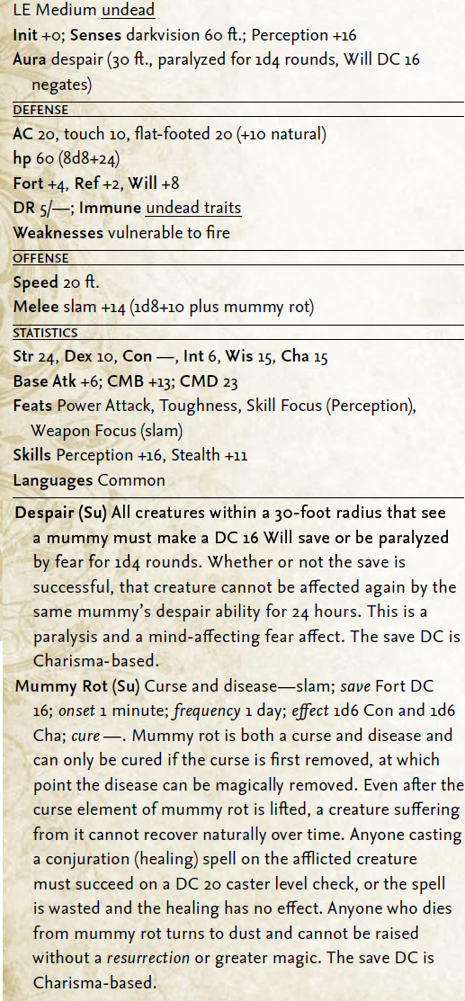
MHORG x2 Knowledge (religion) || DC 23
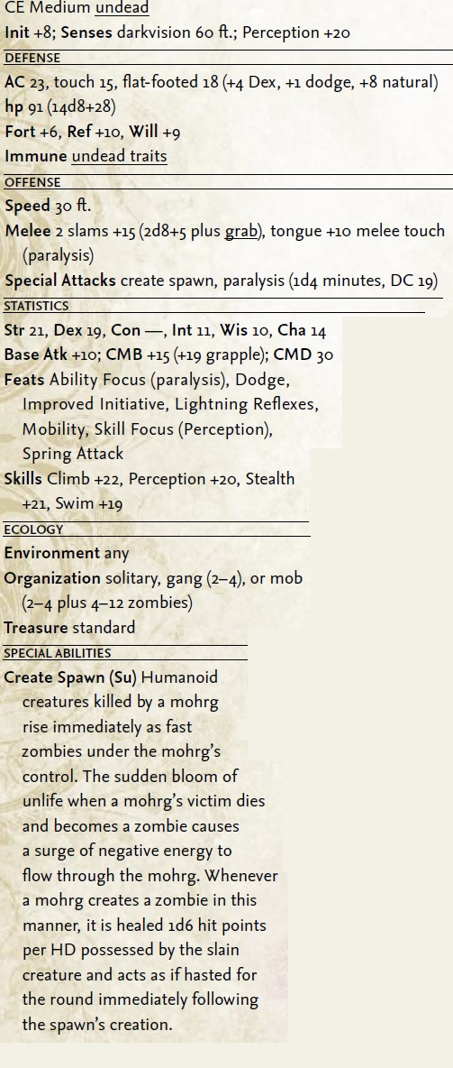
Zahur Spells: (Note that I’m not including everything, just some stuff most GMs aren’t likely to know the rules for off the top of their heads)

Elemental Body II (air): Zahur gains a +4 bonus to Dex as well as +3 natural armor. He also gains fly 60 feet (perfect), darkvision 60 feet, and the ability to create a whirlwind.

Cone of Cold: A whopping 60 foot cone, deals LVLd6 (11d6 in this case) of cold damage.

Solid Fog
School conjuration (creation); Level arcanist 4, magus 4, shaman 4, sorcerer/wizard 4, witch 4
Casting
Casting Time 1 standard action
Components V, S, M (powdered peas and an animal hoof)
Effect
Range medium (100 ft. + 10 ft./level)
Effect fog spreads in 20-ft. radius
Duration 1 min./level
Saving Throw none; Spell Resistance no
Description
This spell functions like fog cloud*, but in addition to obscuring sight, the solid fog is so thick that it impedes movement. Creatures moving through a solid fog move at half their normal speed and take a –2 penalty on all melee attack and melee damage rolls. The vapors prevent effective ranged weapon attacks (except for magic rays and the like). A creature or object that falls into solid fog is slowed so that each 10 feet of vapor that it passes through reduces the falling damage by 1d6. A creature cannot take a 5-foot-step while in solid fog. Solid fog, and effects that work like solid fog, do not stack with each other in terms of slowed movement and attack penalties.
*Referenced Fog Cloud information
The fog obscures all sight, including darkvision, beyond 5 feet. A creature within 5 feet has concealment (attacks have a 20% miss chance). Creatures farther away have total concealment (50% miss chance, and the attacker can't use sight to locate the target).

Shout
Source PRPG Core Rulebook pg. 343 (Amazon)
School evocation [sonic]; Level arcanist 4, bard 4, bloodrager 4, magus 4, skald 4, sorcerer/wizard 4
Casting
Casting Time 1 standard action
Components V
Effect
Range 30 ft.
Area cone-shaped burst
Duration instantaneous
Saving Throw Fortitude partial or Reflex negates (object); see text; Spell Resistance yes (object)
Description
You emit an ear-splitting yell that deafens and damages creatures in its path. Any creature within the area is deafened for 2d6 rounds and takes 5d6 points of sonic damage. A successful save negates the deafness and reduces the damage by half. Any exposed brittle or crystalline object or crystalline creature takes 1d6 points of sonic damage per caster level (maximum 15d6). An affected creature is allowed a Fortitude save to reduce the damage by half, and a creature holding fragile objects can negate damage to them with a successful Reflex save. A shout spell cannot penetrate a silence spell.

Protection from Energy
Standard action cast, it gives him the ability to negate the next (12 * caster level) damage of a given element that comes his way.

Hondo Heru’s spells

Disintegrate

School transmutation; Level arcanist 6, magus 6, sorcerer/wizard 6
Casting Time 1 standard action
Components V, S, M/DF (a lodestone and a pinch of dust)
Effect
Range medium (100 ft. + 10 ft./level)
Effect ray
Duration instantaneous
Saving Throw Fortitude partial (object); Spell Resistance yes

Description
A thin, green ray springs from your pointing finger. You must make a successful ranged touch attack to hit. Any creature struck by the ray takes 2d6 points of damage per caster level (to a maximum of 40d6). Any creature reduced to 0 or fewer hit points by this spell is entirely disintegrated, leaving behind only a trace of fine dust. A disintegrated creature's equipment is unaffected.

When used against an object, the ray simply disintegrates as much as a 10-foot cube of nonliving matter. Thus, the spell disintegrates only part of any very large object or structure targeted. The ray affects even objects constructed entirely of force, such as forceful hand or a wall of force, but not magical effects such as a globe of invulnerability or an antimagic field.

A creature or object that makes a successful Fortitude save is partially affected, taking only 5d6 points of damage. If this damage reduces the creature or object to 0 or fewer hit points, it is entirely disintegrated.

Only the first creature or object struck can be affected; that is, the ray affects only one target per casting.

Wall of Force

School evocation [force]; Level arcanist 5, magus 5, sorcerer/wizard 5
Casting Time 1 standard action
Components V, S, M (powdered quartz)
Effect
Range close (25 ft. + 5 ft./2 levels)
Effect wall whose area is up to one 10-ft. square/level
Duration 1 round/level (D)
Saving Throw none; Spell Resistance no
Description
A wall of force creates an invisible wall of pure force. The wall cannot move and is not easily destroyed. A wall of force is immune to dispel magic, although a mage's disjunction can still dispel it. A wall of force can be damaged by spells as normal, except for disintegrate, which automatically destroys it. It can be damaged by weapons and supernatural abilities, but a wall of force has hardness 30 and a number of hit points equal to 20 per caster level. Contact with a sphere of annihilation or rod of cancellation instantly destroys a wall of force.

Breath weapons and spells cannot pass through a wall of force in either direction, although dimension door, teleport, and similar effects can bypass the barrier. It blocks ethereal creatures as well as material ones (though ethereal creatures can usually circumvent the wall by going around it, through material floors and ceilings). Gaze attacks can operate through a wall of force.

The caster can form the wall into a flat, vertical plane whose area is up to one 10-foot square per level. The wall must be continuous and unbroken when formed. If its surface is broken by any object or creature, the spell fails.

Cloudkill

School conjuration (creation) [poison]; Level arcanist 5, magus 5, sorcerer/wizard 5, witch 5
Casting Time 1 standard action
Components V, S
Effect
Range medium (100 ft. + 10 ft./level)
Effect cloud spreads in 20-ft. radius, 20 ft. high
Duration 1 min./level
Saving Throw Fortitude partial; see text; Spell Resistance no
Description
This spell generates a bank of fog, similar to a fog cloud, except that its vapors are yellowish green and poisonous. These vapors automatically kill any living creature with 3 or fewer HD (no save). A living creature with 4 to 6 HD is slain unless it succeeds on a Fortitude save (in which case it takes 1d4 points of Constitution damage on your turn each round while in the cloud).

A living creature with 6 or more HD takes 1d4 points of Constitution damage on your turn each round while in the cloud (a successful Fortitude save halves this damage). Holding one's breath doesn't help, but creatures immune to poison are unaffected by the spell.

Unlike a fog cloud, the cloudkill moves away from you at 10 feet per round, rolling along the surface of the ground.

Figure out the cloud's new spread each round based on its new point of origin, which is 10 feet farther away from the point of origin where you cast the spell.

Because the vapors are heavier than air, they sink to the lowest level of the land, even pouring down den or sinkhole openings. It cannot penetrate liquids, nor can it be cast underwater.

