3-26 Portal of the Sacred Rune – Vertical Layout
Height from Water | Area/Hazard | Falling Damage
170 | Opening | 13d6+2d3NL
160 | Rune 1 | 12d6+2d3NL
150 |  | 11d6+2d3NL
140 | Rune 2 | 10d6+2d3NL
130 |  | 9d6+2d3NL
120 | Rune 3 | 8d6+2d3NL
110 | Area C | 7d6+2d3NL
100 | Rune 4 | 6d6+2d3NL
90 | Area D | 5d6+2d3NL
80 | Rune 5 | 4d6+2d3NL
70 |  | 3d6+2d3NL
60 | Rune 6, Area E | 2d6+2d3NL
50 |  | 1d6+2d3NL
40 | Rune 7 | 2d3NL
30 | Area G (approx.) | 1d3NL
20 | Rune 8 | None
10 |  | None
0 | Areas H & I | N/A
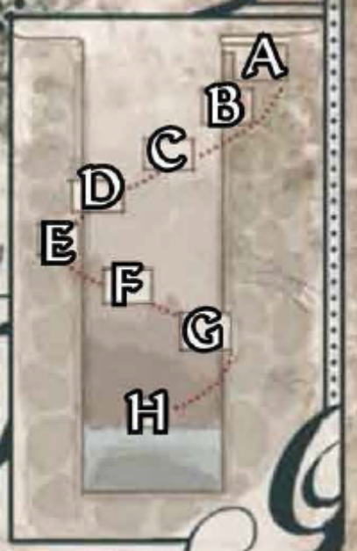
Runes: Starting 10 feet below the shaft's lip and recurring every 20 feet after, rings of anti-magic runes surround the well's circumference. These runes activate if any living being size Small or larger passes them slower than falling speed in a downward direction; creatures within the temple can fly or jump up the shaft but cannot return without triggering the anti-magic rings. Every creature or object within the rune circle's diameter is affected by a targeted greater dispel magic spell (CL nth). Each circle of runes can only activate once per hour, but there are a total of eight circles to pass through from the shaft's lip to the water below. One set of dispel runes activating causes all the others within the shaft to glow a livid green for a minute afterward; even if someone's flight is not disrupted by the first dispel attempt, it should be clear that there are more to come.

