PFS Scenario #6-05: Slave Ships of Absalom
"Take 10" Knowledge

Mission: Investigate the source of a slave-linked scrying sensor on behest of Lady Darchana Madinani, pursuing the creator if deemed necessary.

Location: Absalom, the so-called City at the Center of the World. The teeming metropolis is home to over 300,000 souls and made up of numerous districts that cater to nearly every taste imaginable. As one of the largest seaports in the Inner Sea region, the city is a perpetually changing canvas of ships, cargo, and crew. Absalom is split into several districts:
- Ascendant Court: the Ascendant Court is the religious center of Absalom, holding the preponderance of the city's temples as well as the Starstone Cathedral. Located at the physical center of Absalom, it serves as a hub between other districts.
- The Coins: Absalom's main commercial district, where all manner of goods are for sale at any time of day. It is also the location of the controversial slave pits of Absalom.
- The Docks: typically the first sight of any traveller new to the city and the busiest section of Absalom. The area is known to be rough, catering to the sheer number of sailors that arrive in the bay.
- Eastgate: this district is almost entirely residential with many of its inhabitants working elsewhere in the city. The nomarch of the area is also the captain of the First Guard, keeping unruly activity to a minimum.
- Foreign Quarter: lowered taxes for non-citizens in this section of Absalom have made it quite popular for immigrants.
- Ivy District: this affluent district contains the majority of the artistic entertainments of the city as well as a potent drug trade caused by the sensibilities of its wealthy residents.
- Petal District: known for its well-manicured rows of flowers, the Petal District is home to Absalom's oldest and most powerful families, hiding tense politics behind beautiful landscaping.
- Precipice Quarter: the leftovers after a massive tectonic collapse, those still living in the Quarter often have no other choice, being the poorest residents of Absalom.
- The Puddles: also damaged in 4698 A.R., the Puddles houses the most pitiful of the city's inhabitants, though many have found it lucrative to join one of the many gangs found in the district.
- Westgate: perhaps Absalom's oldest district, Westgate is also largely residential with several shops scattered throughout. Most point to it as a model of Absalom's traditions.
- Wise Quarter: home to the office of the Primarch and the city's other governing bodies, the area lends itself to pursuits of the intellectual.

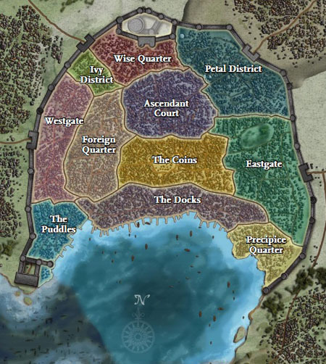
Key NPCs:
- Ambrus Valsin: Venture-Captain and chamberlain of the Grand Lodge in Absalom.
- Lady Darchana Madinani: archdean of the Arcanamirium magical university, she holds a seat on the Lesser Council and advocates for the sharing of magical research.
- Lady Silviana Dimora: an up-and-coming noble, she owns a handmaiden used as the focus for a scrying spell. She is known to work with:
  - Majordomo Milana: the well-trained head of the household staff.
  - Solvius Salbus: a Chelish solicitor known for exceedingly detailed documentation.

Other Information:
- Scrying: a spell used to observe an area around a creature requiring physical knowledge of the subject to link the sensor to the intended target.
- Slavery: ownership of people is legal in Absalom though not widespread. Slaves can only be purchased on Misery Row in the Coins.

