Carving #1 - The Artist



The Artist is depicted painting murals on the walls of impressive buildings, associated with Aroden having painted the city of Absalom with beautiful colours so that it might awe all who visited.

Carving #2 – The Beggar

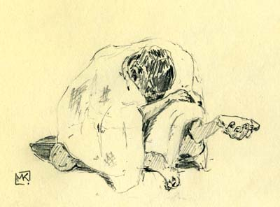

The Beggar is depicted kneeling with an alms bowl raised high, representing Aroden espousing humility in all, lest they forget their shared humanity.

Carving #3 – The Craftsman

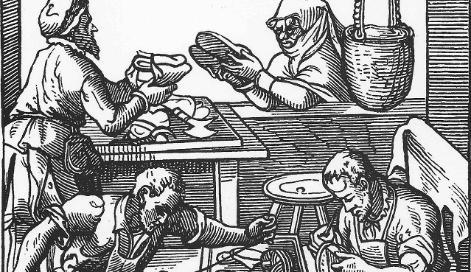

The Craftsman is depicted creating shoes, pots, jewelry, and other moveable goods, referencing Aroden’s delight at seeing his people express their ingenuity in creating new products from raw materials.

Carving #4 – The Farmer
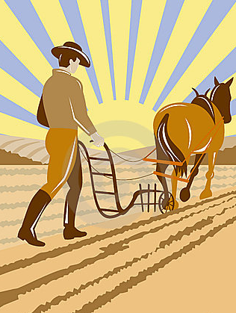

The Farmer is depicted plowing four lines in a field, retelling Aroden’s prophecy that humankind would prepare the rocky earth for planting and over generations wear the pebbles down into fertile soil.

Carving #5 – The Fisherman


The Fisherman is depicted hauling in an enormous catch of small fish to take back to Absalom, illustrating Aroden’s declaration that a great host of creatures could accomplish a great task, whether that be taming the wilds or feeding a nation.

Carving # 6 – The Hunter

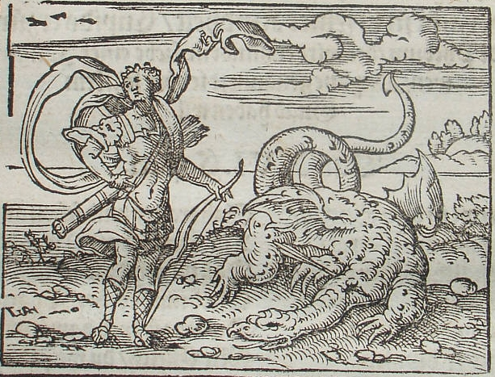

The Hunter is depicted slaying a giant serpentine creature and then parading a trophy through the city streets—a sign to all humanity that the wilds are safe to inhabit once the monsters are slain.

Carving #7 – The Merchant

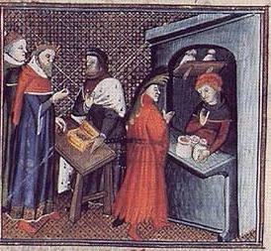

The Merchant is depicted weighing and trading coins of different sizes, a reference to the holy text’s proverb that peace brings trade and prosperity to all people.

Carving #8 – The Scholar

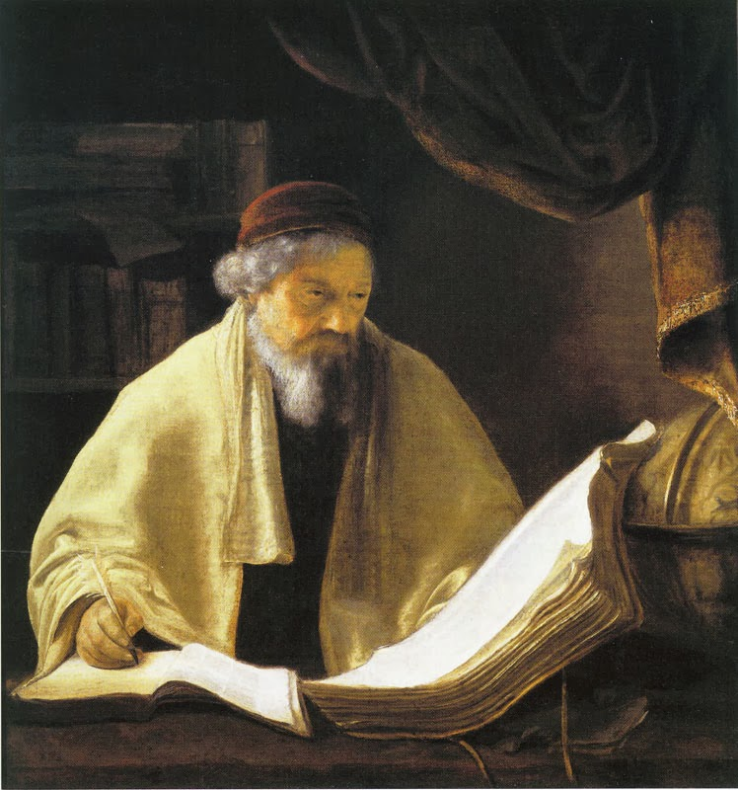

The Scholar is depicted writing on a piece of parchment and then reading from it to passersby, just as Aroden was said to smile on those who recorded history and other knowledge to share it with others.

Carving #9 – The Shepherd

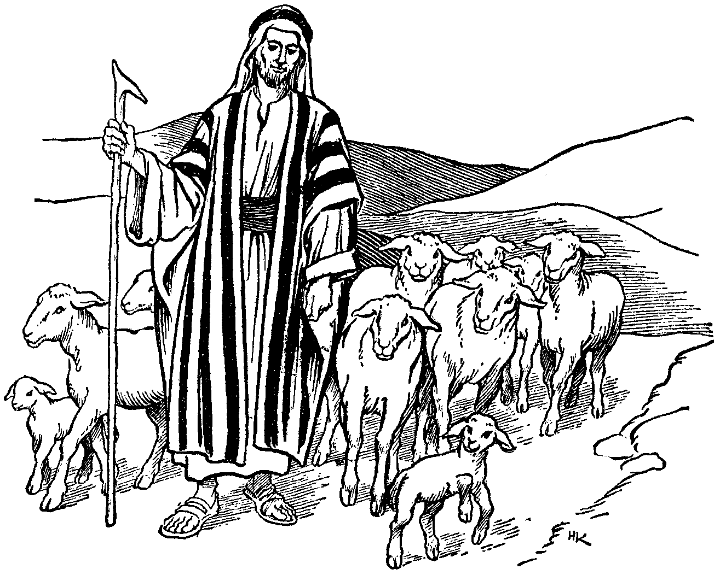

The Shepherd is depicted herding animals out of a crowded city to the pastures beyond, just as Aroden blessed leaders with the foresight to direct people to the tasks and places that best suit them.

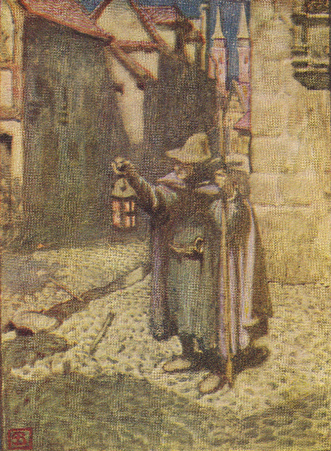
Carving #10 – The Soldier

The Soldier is depicted bearing a lantern through the streets of a city, following the dead god’s prophecy that the vigilant shall carry light to the darkest corners of the world to banish the shadows.

Carving #11 – The Tailor
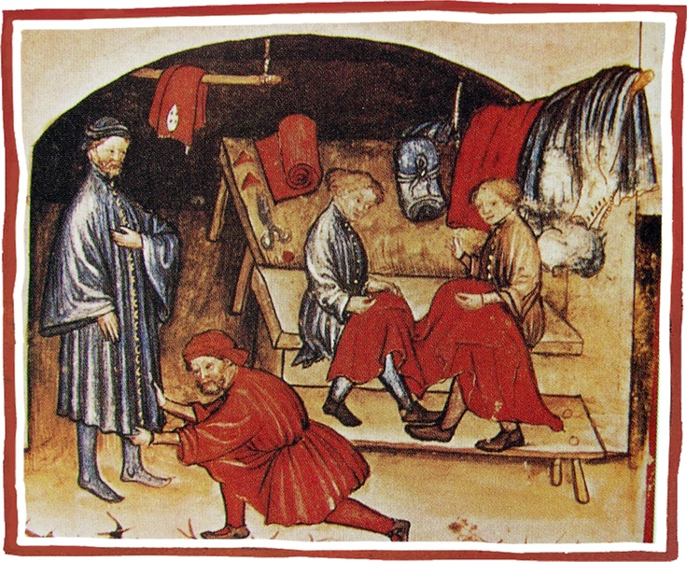

The Tailor is depicted sewing together a long cloth of featuring many patterns that wraps around a city like a moat, referencing Aroden’s proclamation that when the fate of all peoples is woven together, it shall be humanity’s greatest strength.

Carving #12 – The Thief

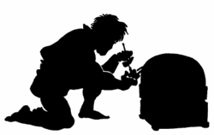

The Thief is depicted stealing a gem from a shop while whispering a prayer, an allusion to a passage saying that larceny—though illegal—is a form of praise, for anything worth stealing is also worthy of praise for its craftsmanship.

