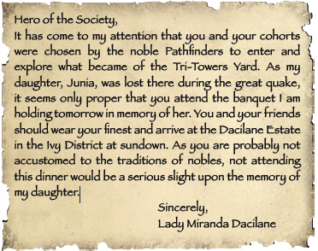
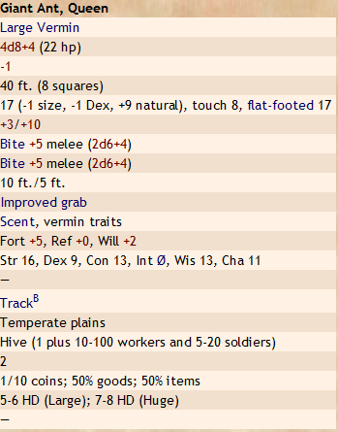

Bugbear zombie;
CR 2; Medium undead;
HD 6d12+3; hp 42;
Init +0; Spd 30 ft. (6 squares; can't run);
AC 16 (+5 natural, +1 shield), touch 10, flat-footed 16;
Base Atk +3; Grp +6; Atk +6 melee (1d8+3, morningstar)
or +6 melee (1d6+3, slam) or +3 ranged (1d6+2, javelin);
SQ Single actions only,
damage reduction 5/slashing,
darkvision 60 ft., undead traits;
Fort +2, Ref +2, Will +5;
Str 17, Dex 10, Con -, Int -, Wis 10, Cha 1

