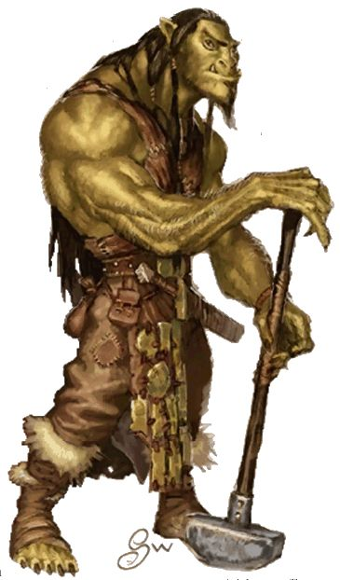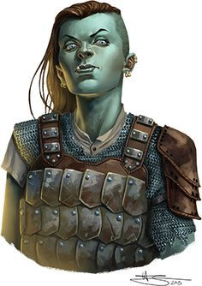

**Gutter**, male ore waterboy and junk-tzar: This hunched, pot-bellied, loin-cloth-wearing ore smells like the river he travels. Gutter trudges the river upon a small barge, toting water, his primary income, from the west to Ooze's banks every few hours; the locals buy it from him and distribute it deeper into the city via carts. Gutter also dredges the river for useful, discarded items. Gutter isn't used to talking to people, so he initially just stares at anyone asking him questions.

**Sheraeda**, female half-ore gambler: Sheraeda is a successful gambler in Urglin. She drinks her mornings away in the Scarlet Ettin in Warmouth, and can be found at the Bloodworks in the early afternoon to evening. She occasionally pilfers the pockets of arena-goers to fund her gambling. She sometimes kills those who affront her.

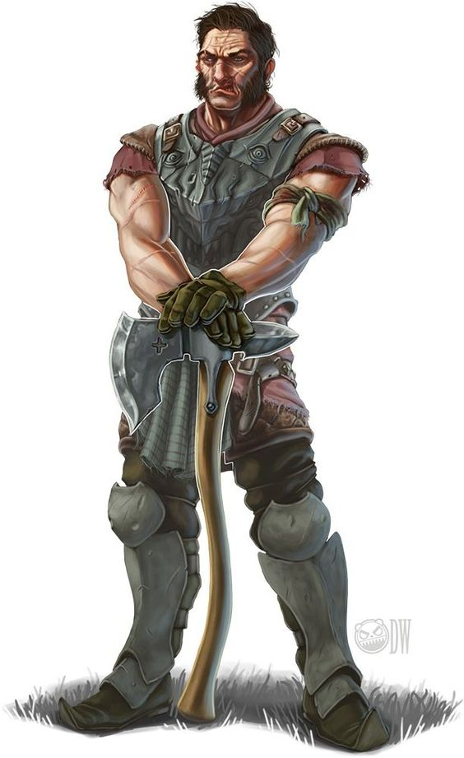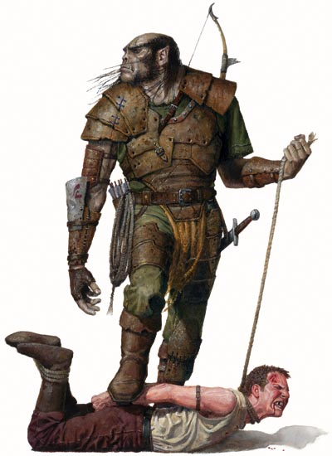

**Dorost**, male human leather merchant: Dorost is a pushy traveling leather salesman. He has three saddles still tainted with ash and blood from when ores cut down his horses for food, and the belts and bags he sells are made from unusual leather. He happily shares what he knows if anyone purchases something from his stall. A PC can recognize that the delicate leather products are made almost exclusively of humanoids with a successful DC 15 Craft (leatherworking) or Survival check.

**Masher**, male ore bounty hunter: This heavily muscled ore carries a spiked club and has a severed half-ore head hanging from his belt. He is in Bonerattle or nearby to collect a reward from the Bonecarvers at the temple of Rovagug for the death of a known priest-killer. He'll tell the PCs about Kline going into Pinkskin for free, as he wants information on the man's whereabouts himself. He knows Ploog would offer a good reward to put that man in the Bloodworks.

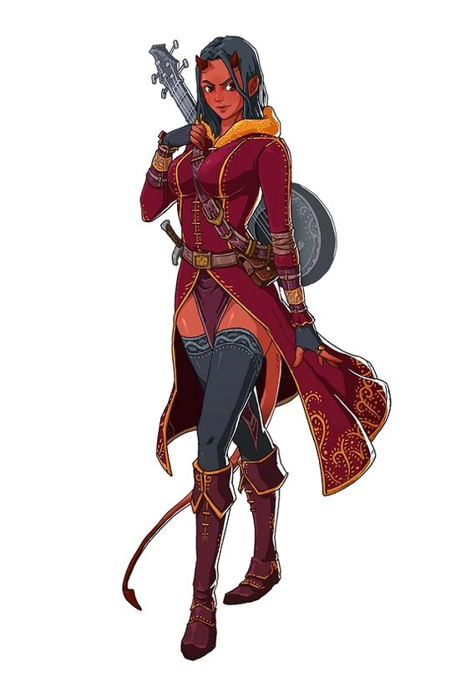

Madiskaal Erindor, female tiefling minstrel. A tiny Chelaxian (4'7'') of indeterminate age and dressed in finery and brimming with jewels, Madiskaal is one of Urglin's richest citizens. She is always accompanied by four ores, two of whom usher her about on a litter and a comely, bare-chested human male. She is one of the primary information brokers in Urglin, and she often shares her discoveries by writing scandalous and slanderous songs. She considers her time valuable and charges 5 gp for 10 minutes of her time, but she waives the fee if she is convinced that she can learn a juicy secret in return.