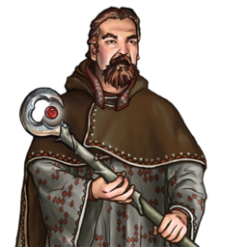
Basics
- Determine terrain DC.
- Asses group basic progress: 4 hour base speed/10 (take the lowest in the party)
- Advantages or tactics.
  - First multiply or divide due to tracking, hustling or other
  - No reroll, no taking 10 or 20, no temp modifiers.
  - Failing Advantage: -1 personal progress, unless otherwise specified.
  - Failing by 5 or more: -1 Group progress, unless otherwise specified.
  - Excess progress is carried over.

Simple advantages (+1 group advantage)
  - Climbing lead (hill or mountain): Climb
  - Evade hazards (any): Survival
  - Fancy footwork (any): Acrobatics
  - Know the area (Any): Know(geography)
  - Know the terrain (any): Know(nature)
  - Notice Shortcut (any): Perception
  - Professional opinion (any): any relevant profession checks.

Other Simple (Personal progress is halfed)
  - Craft or modify tool: Craft (dc 15+/-) with 2 checks/phase.
  - Gather supplies*: food/water (any): Survival (one person Dc 10) +1 person pr. 2 over dc.
  - Gather supplies*: components (any): Know(arcane, nature), spellcraft, survival. Only natural accruing components.

Individual Tactics.
  - Recovery: Can cast heal spells but -5 on gaining advantage.
  - Special movement: 4+ hours of special movement (fly, swim) moves faster, but hard to follow trail.

Group Tactics
  - Forced march: +1 phase/day, but start (dc 10 fort - 1d6 non-lethal + fatigue) and end (dc 14 fort - 1d6 nonlethal and fatigue or exhausted)
  - Hustle: group progress +1 once (second time = 1 non-lethal + fatigue) and -5 to gain advantage other then movement based.

- Compare to tile.

* The gather supplies advantage does not count against the normal limit of advantages allowed for a terrain tile, and it can be used even in tiles which allow 0 advantages.

