Ember, The Chronicler  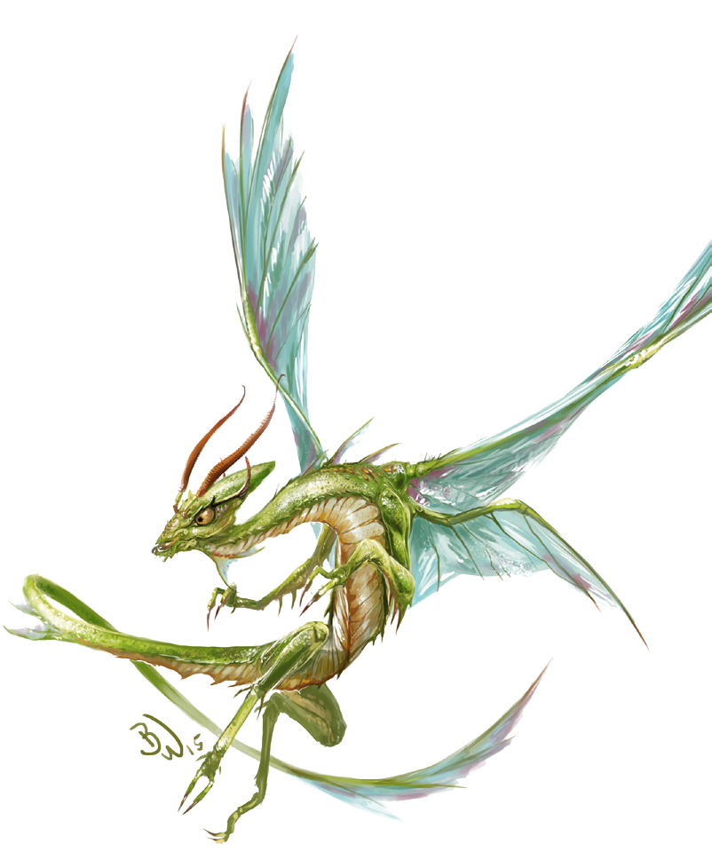  Female advanced pyrausta bard  Ember’s wanderlust and persistent optimism drive her to inspire allies wherever she travels. Foes who underestimate her because of her tiny size soon learn the error of their ways. |  | 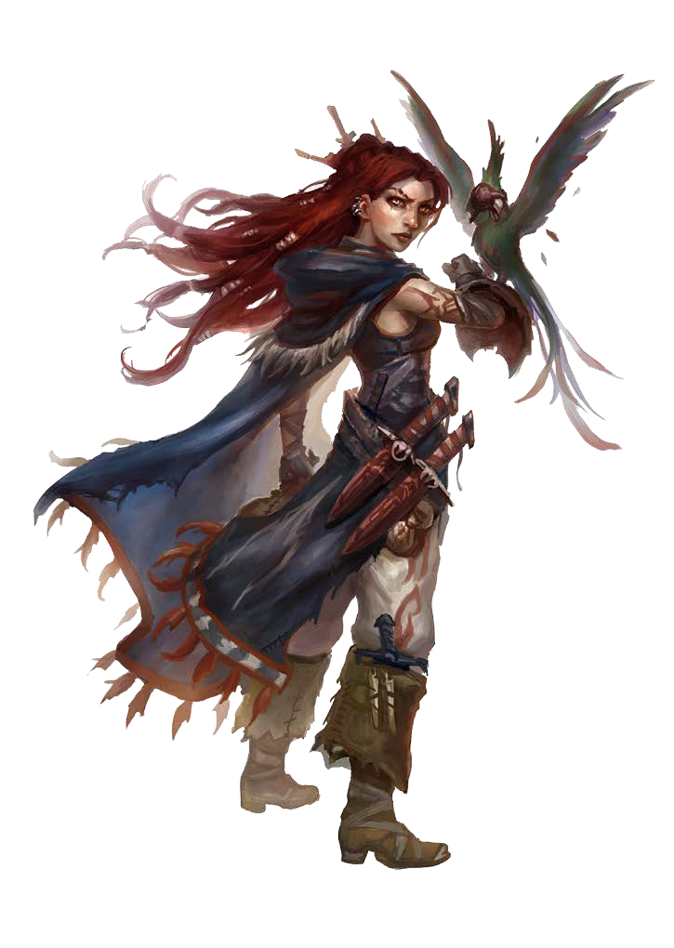  Jamila, The Genie  Female janni aristocrat  After centuries of adventures in Qadira, Jamila’s travels have led her back to the Concordance, where she hopes to regain the place she once held within the organization.
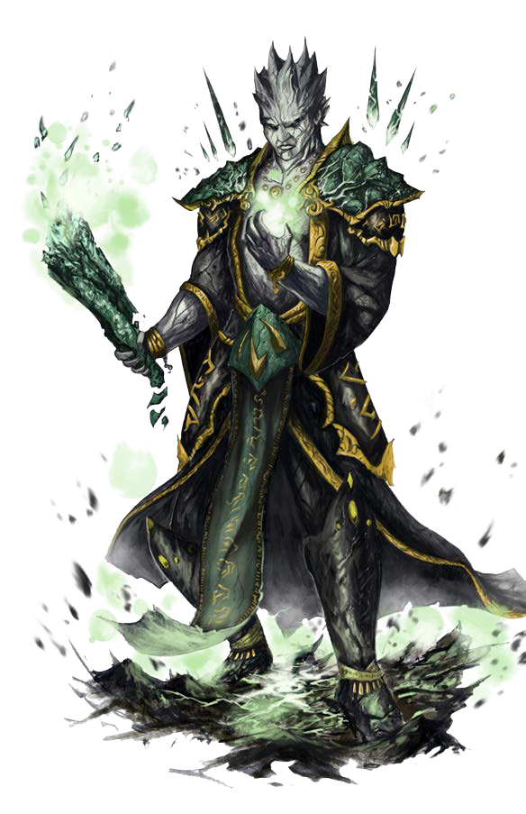  Krakos, The Avalanche  Male Oread Inquisitor of Ayzrul  Krakos’s devout worship of an elemental lord makes him something of an outlier in the Concordance, but he deftly balances the duties of faith  and his pursuit of the Concordance’s goals. |  | Octaris, The Torrent  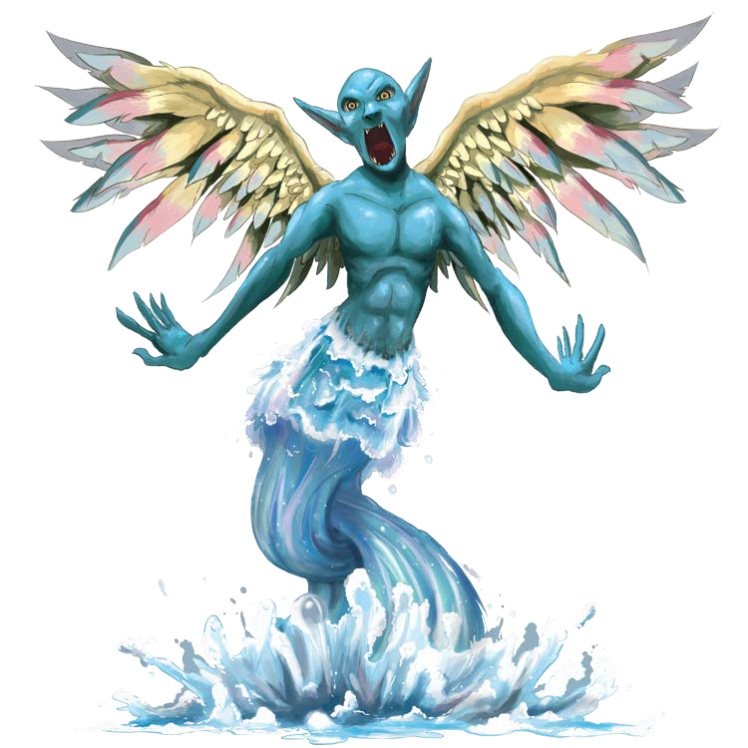  Male water mephit hydrokineticist  Octaris’s penchant for mischief ensures that all is never as it seems when he is around.
Ryhol, The Volcano  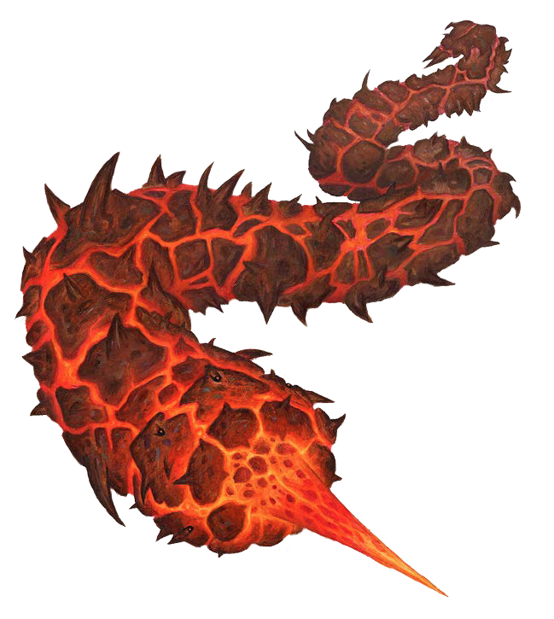  Female thoqqua barbarian  Since achieving the impressive feat of developing a way to make intelligible words out of the steam that emerges from her molten, plated body, Rhyol has sought to prove herself among races conditioned to think of thoqquas as simpleminded worms. |  | 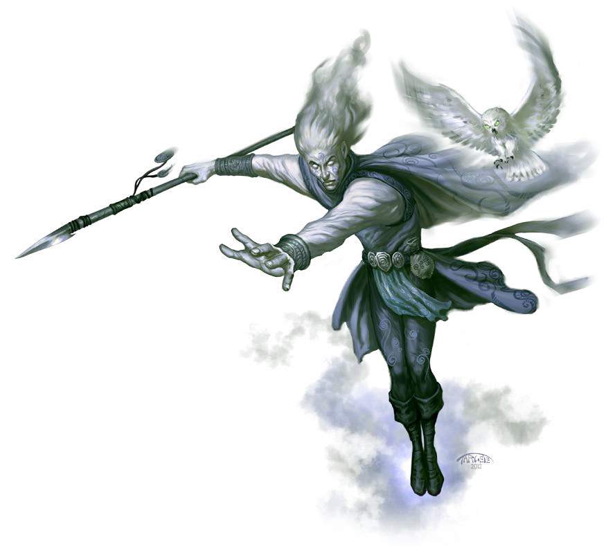  Zephyr of the Forgotten Storm  Male sylph sky druid  Zephyr is a troubled man whose uncanny insights intermingle with baffling leaps of logic.

