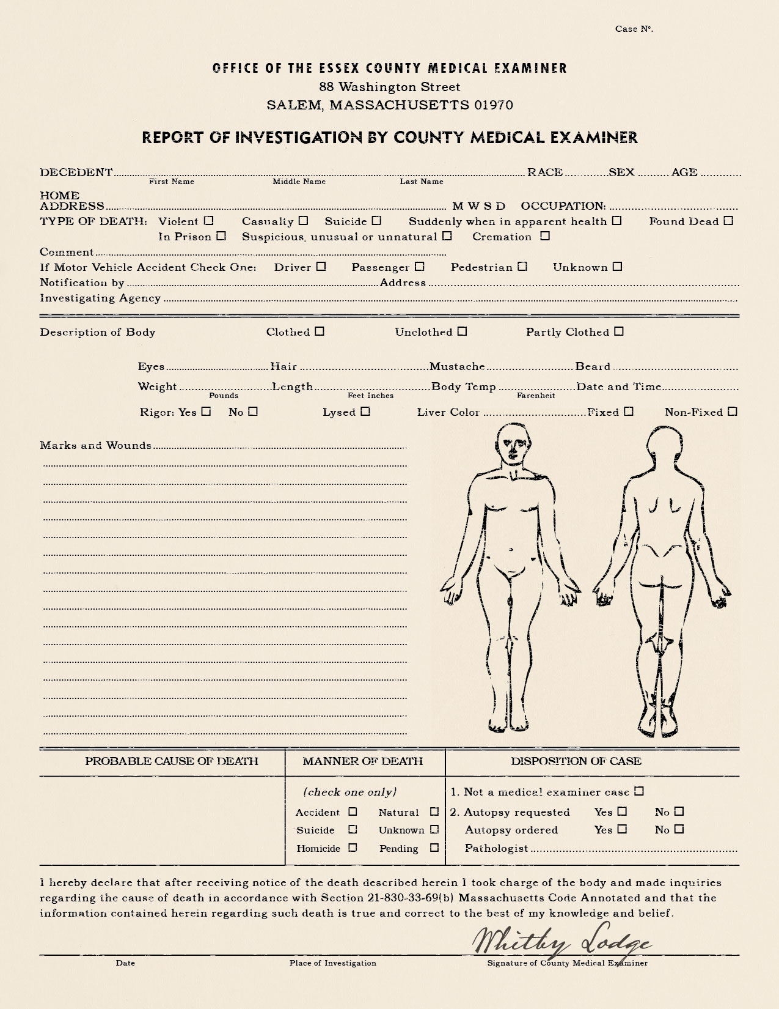

X

X

X

X

X

X

X

5-9 Slipper District

Act of God(s)?

The body has been twisted twice around at the waist like a knotted rag and whose arms are broken in so many places that they flop like tentacles. His chain shirt and sword are twisted like the rest of his body—whatever did this to the man was huge and incredibly strong

240 5’9” 98.0 3 pm

Brown Black Yes Yes

Carrion Hill City Guards/ Volunteers

One of three found- all with similar wounds

89 North Carriage Street City Guard

Margus Austiv Hemmerburg Human M 27 27

**Carrion Hill City Guard**

**Slipper Market District**